# Phan tich dac ta

CRUD

- object

+ Id (Long)

+ DisplayName

+ IdUnit

+ IdSupplier

- unit

+ Id

+ DisplayName

- supplier

+ id

+ displayname

+ address

+ phone

+ email

+ moreInfo --> thong tin misc

+ contractDate --> ngay hop tac

- Customer

+ id

+ displayname

+ address

+ phone

+ email

+ moreInfo --> thong tin misc

+ contractDate --> ngay hop tac

- input ( phieu nhap )

+ Id

+ dateInput

- inputInfo ( mot phieu se co nhieu mon hang / input contains many inputInfo )

+ idObject

+ Id input

+ Count

+ InputPrice

+ outputPrice

+ status

- output ( phieu xuat )

+ Id

+ dateOutput

- OutputInfo

+ Id

+ IdInputInfo

+ Count

+ IdCustomer

+Status

- report view every time table changed

# Material design in xaml toolkit

# MVVM

App start flows:

Xaml (view)

Code behind

Uu diem:

update se nhanh hon

Tách riêng giao diện, code event

Nhược điểm:

Lúc đầu code sẽ chậm

Một số trường hợp khó xử lý

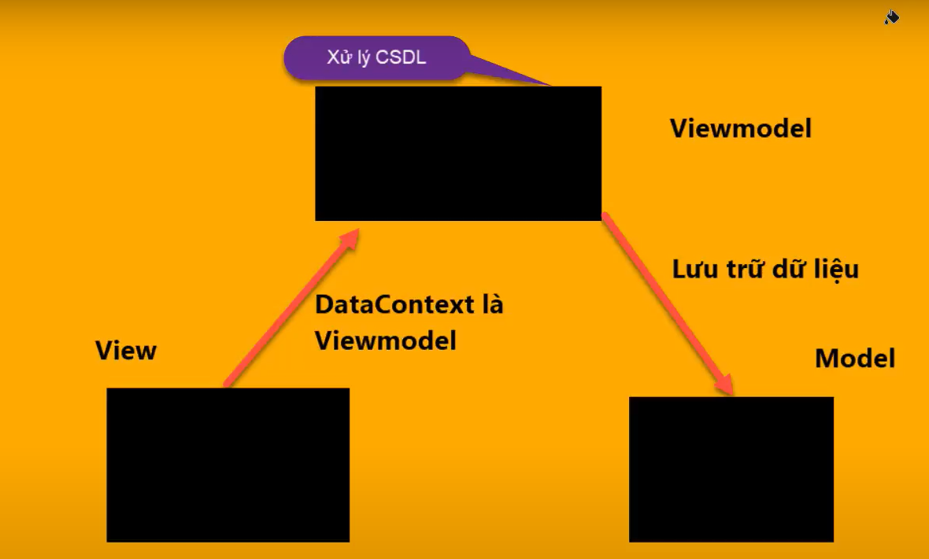

# Create MVVM standard project

Contains 2 projects ( or folders) :

One for model

One for view-model

ModelView --> process all events

View + code behind --> difficult for teamwork

View + view model --> view and business logic can grow independent

# Investigate

Datacontext

Event